Task 5: Design a feedback form interface that displays submitted data dynamically on the screen.
App.jsx
import FeedbackForm from "./FeedbackForm";

function App() {
return (
<div>
<FeedbackForm />
</div>
);
}
export default App;

FeedbackForm.jsx
import { useState } from "react";
function FeedbackForm() {
const [formData, setFormData] = useState({
name: "",
email: "",
message: "",
});
const [submissions, setSubmissions] = useState([]);
const handleChange = (e) => {
const { name, value } = e.target;
setFormData({ ...formData, [name]: value });
};
const handleSubmit = (e) => {
e.preventDefault();
setSubmissions([...submissions, formData]);
setFormData({ name: "", email: "", message: "" });
};
return (
<div style={{ maxWidth: "500px", margin: "20px auto" }}>
<h2>Feedback Form</h2>
<form onSubmit={handleSubmit}>
<input
type="text"
name="name"
placeholder="Your Name"
value={formData.name}
onChange={handleChange}
required
/>
<br /><br />
<input
type="email"
name="email"
placeholder="Your Email"
value={formData.email}
onChange={handleChange}
required
/>
<br /><br />
<textarea
name="message"
placeholder="Your Feedback"
value={formData.message}
onChange={handleChange}
required
/>
<br /><br />
<button type="submit">Submit</button>
</form>
<hr />
<h3>Submitted Feedback</h3>
{submissions.map((item, index) => (
<div key={index} style={{ border: "1px solid #ccc", padding: "10px" }}>
<p><strong>Name:</strong> {item.name}</p>
<p><strong>Email:</strong> {item.email}</p>
<p><strong>Message:</strong> {item.message}</p>
</div>
))}
</div>
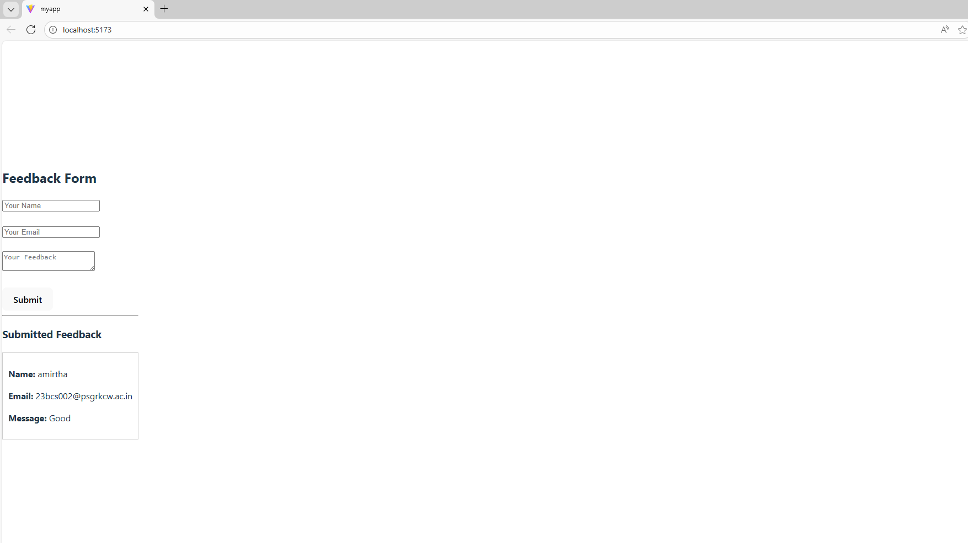
);export default FeedbackForm;

